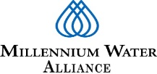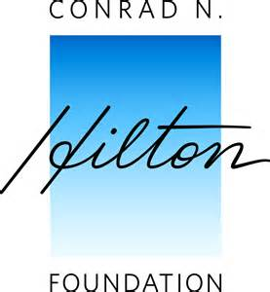

Millennium Water Alliance Ethiopia Program (MWA EP) Bridge Program Completion Report
Grantee | Millennium Water Alliance (MWA)
Grant Number | 17287
Grant Period | December 1, 2017 - March 31, 2019
Grant Amount | $1,500,000
Report Period | December 1, 2017-March 31, 2019
Report Period Budget | $ 1,500,000
Report Period Amount Spent | $ xxx
Report Period Variance | $ xxx
Report Due Date | April 30, 2019
Report Prepared By | Mussie Tezazu
Title | Monitoring, Evaluation & Learning Manager 7
Phone | +251 (91) 188 9166
Email | mussie.tezazu@mwawater.org
List Any Contact Changes | None
Date submitted | April 30, 2019

Introduction
The Millennium Water Alliance is a coalition of leading international charities helping to bring safe drinking water, improved sanitation and hygiene services to the world’s poorest people in Africa, Asia and Latin America. MWA works with governments, corporations, foundations and other NGOs to advance best practices, share knowledge, build collaboration and advocate for greater commitment to achieve sustainable WASH services. MWA has been implementing WASH programs in Ethiopia since 2004. The current Conrad N. Hilton Foundation (CNHF) supported ‘Bridge Program’ in three woredas of Amhara region is the collective work of MWA and members that include: CARE, Catholic Relief Services, FH Ethiopia, Helvetas, WaterAid and World Vision. In addition, strategic partners such as IRC WASH, Splash, CDC and Stanford University have also actively involved during the program period in providing technical support for the successful completion of different assessments and long-term SDG plan preparation for three target districts. While various members focused on specific aspects of the program, the results are presented collectively as the work of the MWA. Please kindly note that in all discussions where “MWA” is mentioned are meant to be inclusive of the program members and strategic partners as a whole though extent of engagement vary depending on program components.
Executive Summary
The Millennium Water Alliance (MWA) Bridge Program demanded the adoption of an integrated and comprehensive systems-based approach to WASH service delivery with a clear goal aimed at contributing to achievement of universal coverage. The aim to make progress towards the Sustainable Development WASH goal 6.1 &2 has necessitated a significant change from the conventional water access approach into an emphasis on supporting systems, institutions and processes towards universal coverage and collaborative efforts on various assessments to capture benchmarks, participatory long-term planning process, system strengthening, partnership development, program design, proposal development, MEL framework preparation, accessing sustainable WASH services at community level and performing different supporting activities at regional and national levels.
This bridge program is intended to contribute to Ethiopia’s achievement of universal, safe and sustainable WASH services delivery nationwide by 2030. More specifically, the Bridge Program is intended to achieve three objectives, these include:
- Replicate and adapt innovations in the water sector: Dispensers for Safe Water and Self-Supply that are aligned with the goals of learning, obtaining evidence about service delivery models and reaching full coverage with safe and sustainable water.
- Develop a detailed five-year MEL framework and program proposal aligned with the CNHF safe water strategy and applicable to the Ethiopian context.
- Develop and/or strengthen internal and external partnerships and program support structures to ensure sustainable WASH services.
This program completion report provides summary of program accomplishments during the bridge period that covered 16 months (December 1, 2017-March 31, 2019). Some highlighted achievements during this reporting period include:
Partnership development: MWA signed a program implementation agreement with Amhara region before the onset of the program. In addition, a memorandum of understanding (MOU) was signed between MWA and all program partners detailing duties and responsibilities of each entity for the successful implementation of program activities. The MOU served as a key protocol to develop and strengthen partnerships and networking with members and government stakeholders that led to the efficient use of resources to meet deliverables. MWA established a strong partnership internally with members and benign working environment with government stakeholders and other WASH actors for the success of the program.
System strengthening: Efforts were exerted to strengthen the MWA consortium internally as well as support structures and processes of government partners at different levels. In this regard, different activities such as: various human and institutional capacity building endeavors at local and regional government structures, improving the backbone roles within the MWA consortium, organizing consultative meetings with pertinent stakeholders, delivering presentations on WASH systems from local and global experiences, sharing learning documents and different trainings were offered on key thematic areas to improve the knowledge-base and skillsets of those government and partners staff who engaged in the program implementation to bring improved systems and process towards achievement of the sustainable WASH services.
Assessment for master planning: A strategic plan aimed at reaching full coverage required a robust assessment of WASH services at household, community & institution levels, local government capacities to manage the water services, explore the existing gaps in service delivery and map out resource acquisition and allocation mechanisms for the WASH sector. In connection to this, MWA and program partners have conducted range of assessments to assess and analyze local and regional context and come-up with doable approaches to achieve full-coverage. Here, MWA utilized a considerable amount of resource (staff time, material and money) for data collection, analysis and generating evidences for planning and decision making. For the assessments, local and regional government staff were actively engaged in the design/review of tools for data collection, the actual field work (data collection), data analysis and generating results. To validate data collected from different sources, assessment findings were presented to district government staff and valuable inputs were incorporated to enrich assessment results.
District-wide long-term WASH strategic planning: Successive regional and woreda level workshops were conducted for planning and capacity building to support the district government in preparing long-term strategic WASH plans that guide WASH interventions over the next 12-year. Three districts prepared a long-term coasted WASH master plan which clearly show the identified WASH needs, the required technology options, human & institutional capacities, available resources and strategies indicative of how the government, MWA consortium, other CSOs and the private sector can collaboratively work to achieve full-coverage by 2030.
Proposal development: MWA followed a participatory and iterative process of program design and proposal development engaging all partners, district and regional government stakeholders that enabled to produce a winning proposal where our generous donor (Hilton Foundation) has allowed the required funding for the implementation of a five-year WASH program, which was designed based on the CNHF safe water strategy and a twelve-year district WASH master plans.
Dispensers for Safe Water Pilot II: MWA in collaboration with Evidence Action, members and government partners has successfully installed 200 chlorine dispensers at community water sources to mitigate issues of water quality at the source and in the household using a chlorine residual to increase water quality through transport and household storage. For the DSW pilot, chlorine dispensers were purchased; necessary trainings and community sensitizations were offered; community water points were selected with government officials using sets of criteria; all the necessary construction materials and liquid chlorine made available; dispenser installation and verification for quality assurance were carried out. In addition, intensive back-checks and adoption monitoring surveys were conducted and the overall up-take level among users was found to be commendable. A total of 57, 450 people have benefitted from 200 chlorine dispensers installed during the bridge period.
Self-Supply Acceleration: The MWA consortium has implemented self-supply in three districts to accelerate household level investment to improve water access and quality for rural communities with scattered settlements that are hard-to-reach by conventional water service delivery. The program could able to create access 3,031 people to safe drinking water through the construction and upgrading of 590 at household self-supply wells. The construction and upgrading of self-supply wells through families own entire investment in water has a significant contribution to increase safe water coverage which in turn increases users’ satisfaction accessing protected water sources either in their compound or near to their dwellings. MWA has continued to collaborate with the local, regional and national government in rolling out self-supply acceleration activities in intervention districts. Intensive demand creation activities were done in the self-supply implementation to enable households move from the lowest, affordable, but risky in terms of water quality, towards more conventional and safer technologies such as pumps, protected wellheads and safe water storage solutions. Several logical steps were followed in the evolution of self-supply acceleration and building demand to get a point where it can be sustained almost completely through market driven approach. Government and partners’ staff attended training on the steps of self-supply; MWA worked with woreda government to determine ideal kebeles for self-supply; partners and government people facilitated community sensitization sessions employing participatory approaches; various IEC/BCC materials were prepared and used for trainings, and relevant information was shared with households on the self-supply ladders and associated costs to get there.
Monitoring, Evaluation & Learning: MEL has been an integral component of the bridge program. MWA and program partners have accomplished different activities as planned. These include: several assessments were conducted to capture baselines for the 12-year strategic plan; development of MEL framework to guide activities of the next five-year program; periodic joint visits were conducted to oversee the status of bridge program activities and take remedial actions on challenges and limitations; program review meetings conducted at woreda and region levels involving pertinent stakeholders; learning and exposure visits conducted in-country and outside of the country (Ghana); different learning documents were produced and shared with local and global WASH actors; several supportive supervisions were conducted to project sites; and technical supports were provided to government and partners staff.
MWA worked closely with members and government partners to maintain a continuous process of planning, monitoring and learning using a shared measurement system. For this, MWA established a Core Design Team and a Technical Working Group, which were comprised of representatives from each program implementing partner in order to coordinate activities related to project design and proposal development; progress review; joint visits and technical backstopping; validation of results of baseline surveys; MEL framework development, and convening of learning and reflection sessions. MWA made use of drop box for shared access to documentation and dissemination of the various planning, monitoring and learning activities accomplished during the bridge program.
MWA has also facilitated extraordinary visits that involved the donor, government officials and program partners to intervention areas to verify progresses, provide technical supports and consult users and local government stakeholders. MWA followed a step-by-step process leading towards development of a strong and detailed MEL framework in line with the 12-year WASH strategic plan aimed at achieving full-coverage by 2030. To strengthen government-led WASH monitoring system, MWA purchased some computers and printers for government, based on the assessed needs of district water offices and the items are ready to be delivered to three districts (Dera, Farta and North Mecha).
Community WASH services: During the bridge program period, a total of 10,202 people gained access to safe water from community schemes developed/rehabilitated through matching funds from program partners. Of those, 5,202 people accessed safe water from new systems and about 5,000 from rehabilitated/upgraded water schemes due to the use of solar power-generated pumps. This has been made possible through construction of 22 new community water schemes. These include 5 hand-dug wells fitted with hand pumps; 10 shallow boreholes; and 7 spot springs with collection chambers. In addition, solar-pumps were installed at 5 community water schemes which were using hand-pumps as lifting device. The change in lifting technology has made water collection easy for women and children as compared to hand-pumps, which most tedious and lengthy to fetch water using own force. Since MWA and partners implement WASH as package, there were intensive sanitation & hygiene promotion activities across project sites to bring behavior change in improved sanitation and good hygiene practice. Accordingly, communities were triggered with CLTSH and 3,491 households constructed their own latrines, which in turn resulted in 15, 710 people have accessed improved sanitation facilities and started to practice good hygiene.
School WASH services: MWA and program partners were able to construct ventilated improved pit latrines (VIPLs) at five public schools serving 4,045 people and rain water harvesting systems were installed at three schools benefitting 4,166 students. In addition, hand washing stations were constructed at five schools. To create suitable environment at schools, separate blocks of VIP latrines with handwashing facilities (for males & females) constructed at schools and school WASH clubs were established and trained to support the sanitation and hygiene promotion activities both at school and in the surrounding communities. Different trainings and awareness creation activities on safe water, improved sanitation and good hygiene were accomplished at targeted schools.

Local capacity building and community empowerment: MWA and partners facilitated intensive capacity building activities to ensure sustainability of WASH services in targeted communities. For this, various trainings provided to government staff, partners experts, community representatives, different community structures established and members trained, several awareness raising and sensitization activities conducted to speed up the water, sanitation and hygiene promotion activities at schools and in communities to bring behavior change in household water treatment & safe storage, utilization of improved toilets and good hygiene practices. The following is just to mention the main achievements:
  - 515 WASHCO members were trained on water schemes management.
  - 18 WASHCOs were legalized and formed Water Users Associations fulfilling all the necessary government requirements
  - 100 water care takers and 16 local artisans attended practical training organized on operation and maintenance of water schemes.
  - 45 district government officials and experts attended training on self-supply. Besides, 3,455 community members participated in the self-supply demand creation training and sensitization facilitated by government and partners staff.
  - 25 government and partners’ staff attended training on improving water quality using chlorine dispensers.
  - 30 government staff from intervention woredas and partners experts were trained on Strategic Planning.
  - Water quality test kits and re-agents were supplied to Woreda Water office and Town Utility for water quality monitoring and testing.
  - 26 district level government experts were trained on knowledge management and communication.
  - 25 government and partner staff attended training on Water Resource Management.
  - 17 MWA and partners staff were trained on the approach and principles of Project Implementation through Facilitated Approach (PIFA).

Detailed Narrative Report

Program Goal, and Expected Results
Goal 1: Replicate and adapt innovations that are aligned to the goals of learning, obtaining evidence about service delivery models and reaching full-coverage with safe and sustainable water.
- Improve the uptake of household level investment in water supply
1.1 Self-supply acceleration activities at national level
MWA and program partners participated in and supported different national events convened on the water sector that paved the way for the consortium to present achievements of the self-supply imitative to the wider actors to enable them consider self-supply as doable service delivery model. During these events, the need for household level investment towards creating access to safe water was emphasized and it was noted that a better understanding about the potentials and buy-in on SSA was created amongst WASYH actors.
In addition, MWA and program partners supported the inclusion of self-supply as a water service delivery model in the checklist prepared for national water inventory to collect and analyze data on the concurrent trends and issues around self-supply. The findings of an end-line evaluation conducted on self-supply intervention of MWA from the 2014-2017 program was shared widely with WASH stakeholders’ in-country.
1.2 Self –supply acceleration activities at region and district level

MWA and three partners implemented self-supply in three districts to uptake household level investment to improve water access and quality for rural communities. The program could able to create access 3,031 people to safe drinking water through the construction and upgrading of 590 at household self-supply wells. The construction and upgrading of self-supply wells through families own entire investment in water has a significant contribution to increase safe water coverage which in turn increases users’ satisfaction accessing protected water sources in near proximity. MWA has continued to collaborate with the local and regional government in rolling out self-supply acceleration activities in three districts. Intensive demand creation activities were done in the self-supply implementation to enable households move from the lowest, affordable, but risky in terms of water quality, towards more conventional and safer technologies such as pumps, protected wellheads and safe water storage solutions. Several logical steps were followed in the evolution of self-supply acceleration and building demand to get a point where it can be sustained almost completely through market driven approach. Government and partners’ staff attended training on the steps of self-supply; MWA worked with woreda government to determine ideal kebeles for self-supply; partners and government people facilitated community sensitization sessions employing participatory approaches; various IEC/BCC materials were prepared and used for trainings, and relevant information was shared with households on the self-supply ladders and associated costs to get there.

The targets set for three woredas was 550 and the achievement has become 590. In order to build the capacity needed for implementation of the SSA aspect of bridge program, a phased approach to government capacity building was delivered through different trainings and sensitization activities targeting the district officials and experts from line offices (water, health, education, administration, women affairs, TVET and enterprises development offices). These included a training workshop, consultative meetings and joint program planning and implementation at the district level.

Self-supply acceleration refresher training and planning workshop was conducted at regional level involving pertinent stakeholders. Following the training and planning workshop, self-supply working groups were established at district level to coordinate the demand creation/sensitization, site selection, technology choice and household level support activities. After the training and planning workshop, self-supply working groups were established at district level to coordinate the demand creation/sensitization, site selection, technology choice, monitoring and household level support activities.

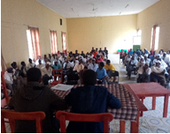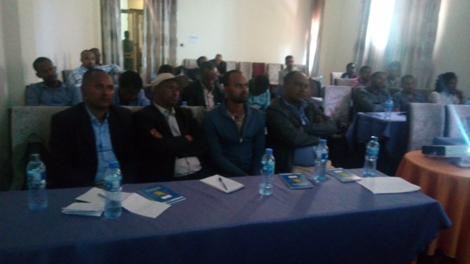

1.3 Self-supply acceleration activities at community level

At the early stage of the bridge program, district and community level potential and gap identification/ assessments were undertaken with the involvement of Woreda WASH Team, WASHCos, local artisans and community representatives. This task was performed after the regional self-supply refresher training and planning workshop. Twenty self-supply potential kebeles were identified and prioritized in three districts based on the standard criterial depicted in the national implementation manual. The self-supply acceleration trainings were cascaded down to kebele and village levels to enlighten government and community structures and help them to support the implementation process. Local officials, health extension workers, development agents, artisans, teachers and community members were in attendance of these discussions and sensitizations. Different context-specific and participatory community education and training methods were employed. District experts and amateur artists facilitated the demand creation activities at community level with proper coordination of implementing partners. As key component of the bridge program, program partners and government stakeholders gave adequate emphasis to the self-supply promotion and demand creation activities engaging local champions and key actors. Below are summary of the local level accomplishments pertaining self-supply.
- Successive trainings were offered on the technical and conceptual components of self-supply water service delivery. These trainings helped district and kebele level actors acquire basic knowledge and skills of self-supply and use of rope pump as a viable lifting technology option.
- Experience sharing visits and demonstrations were conducted on well-digging, pump installation and construction of superstructure at selected sites where model households reached at the highest level of the self-supply ladder.
- Technical advices and awareness rising supports were provided to households on the multiple use of water to enable them utilize their family sources for domestic and productive uses.
- Private service providers and local artisans attended trainings and consultative meetings to stimulate their engagement in self-supply accessing products and services.
- A participatory and demand-responsive screening process was applied to identify and support those capable households who invested for their water source. Close follow-up and technical backstopping were provided during site selection, head-works and pump installation to ensure quality of construction.
- Government experts and artisans supporting self-supply trained on rope pump manufacturing, installation and maintenance by a private consultant who worked long in the sector. JICA’s guidelines prepared on rope pump were provided to participants to use as references.
- Technical support and guidelines were provided to rope pump manufacturers to enable them use the latest specification/standard process to ensure/improve quality of the rope pumps.
- Practical training on rope/afridev pumps installation and maintenance were provided to government and partners staff. The trainings helped to create local level capacity on point source development. For instance, the number of technicians working on rope pump increased from 3 to 17 in North Mecha district.
- Community groups, amateur artists, volunteers, religious leaders and model households participated in the intensive demand creation and sensitization that resulted in 590 households to develop/upgrade their family wells with their entire investment.
- The demand creation endeavor through community promoters made a difference specially in upgrading family wells. This has happened due to the attention given to community promoters who have been delivering key messages at churches and public gatherings, priority was given to interested households coupled with the experience sharing visits to the nearby villages where model self-supply farmers show-case their water point explaining the multi-faceted benefits from the facilities. Here, the experience from North Mecha district could be mentioned as notable example since a total of 86 people participated in the inter-kebele experience sharing visits.
- There was also an inter-district learning and experience sharing visit that engaged government and partners’ technical staff aimed at learning from practice specifically on community level demand creation, technology choice and private sector engagement.
- MWA, program partners and local government stakeholders’ demonstrated high level commitment to demand creation and community engagement in self-supply activities with close-follow up targeting households that had expressed high interest to own their water points.

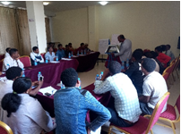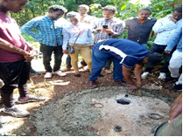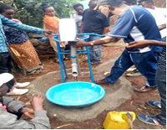
Fig 2: Rope pump manufacturing, installation and maintenance training; theoretical session(left); practical (middle & right)

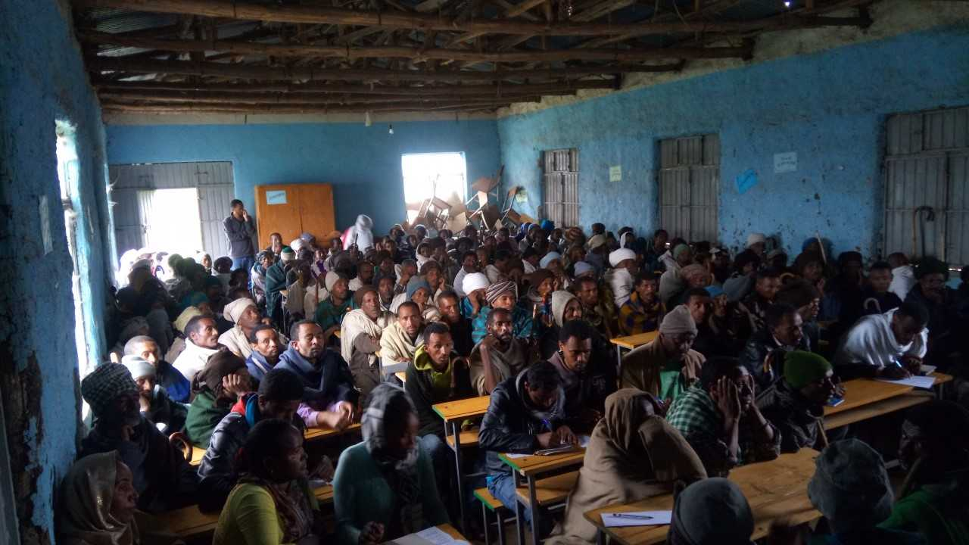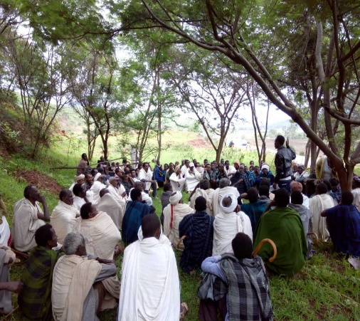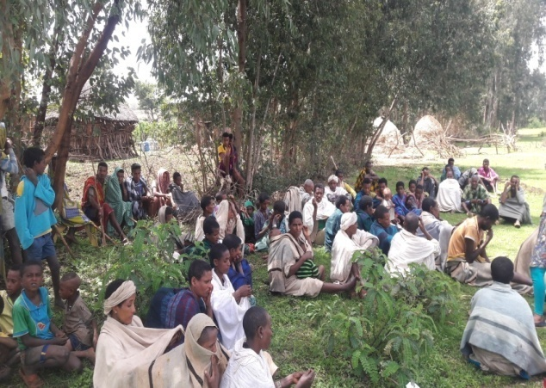
Fig 3: People attending community level self-supply sensitization sessions

1.4 Stimulate private sector engagement in self-supply
Local artisans, masons and well-diggers have actively engaged in the self-supply sensitization activities and provided the necessary supports to households who developed/upgraded their family wells. These segment of the community have supported the SSA work in accessing products and services required for well-digging, construction of head-works and installation of lifting devices (rope pump and afridev hand-pump). During the reporting period, local artisans and spare part suppliers participated in different meetings: program inception meetings, launch events and review meetings conducted at district level. Considering the lessons from the previous grant (2014-2017), refresher training on rope pump manufacturing and installation was offered to government experts and rope pump manufacturers in North Mecha district to ensure quality and sustainability of rope pumps.
Table 1: Outputs from household self-supply acceleration
Indicator | Target | Achieved | # of Users
# of household with new self-supply wells | 350 | 198 | 1,053
# of household with improved/upgraded self-supply wells | 200 | 392 | 1,978
# of household loans taken for self-supply | 50 | - | -
Learning outputs developed for SSA | 4 | 3 | N/A
# of artisans or private entrepreneurs trained | 20 | 21 | N/A
# of community members sensitized about SSA | 2,750 | 4,742 | N/A
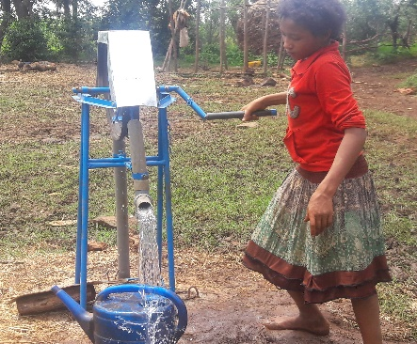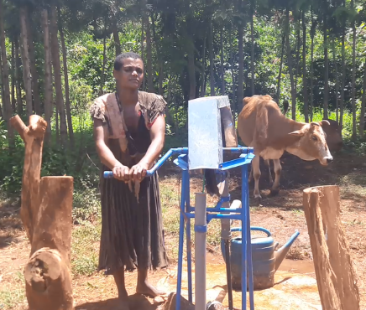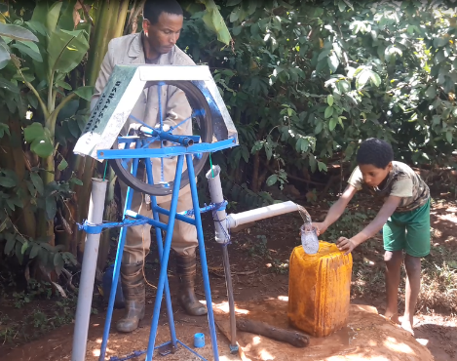
Fig 4: Family members collecting water from self-supply wells in North Mecha district

- Dispensers for Safe Water (DSW)
MWA in collaboration with Evidence Action, members and government partners has successfully installed 200 chlorine dispensers at community water sources to mitigate issues of water quality at the source and in the household using a chlorine residual to maintain water quality during collection, transport and household storage. For the dispensers for safe water pilot, chlorine dispensers were purchased; necessary trainings and community sensitizations were offered; community water points were selected with government officials using sets of criteria; all the necessary construction materials and liquid chlorine made available; dispenser installation and verification for quality assurance were carried out. In addition, intensive back-checks and adoption monitoring surveys were conducted and the overall up-take level among users was found to be commendable. A total of 57, 450 people have benefitted from 200 chlorine dispensers installed during the bridge period.
Chlorine dispenser is a new technology that MWA started implementing in Farta district working in collaboration with Evidence Action a year ago to address issues of water quality at source and in the household. Looking at the successes and lessons from previous pilot, MWA and program partners incorporated DSW as key component of the bridge program extending the scope into three districts. Below, you will find summary of the key steps followed.
2.1 Technology introduction and familiarization workshop
Dispensers for safe water training of trainers was held at regional level where 25 government and partners’ staff were in attendance. Afterwards, district level familiarization workshops were held at three centers aimed at sensitizing stakeholders and collaborators about chlorine dispensers, key steps, actors roles and responsibilities as well other components and activities entailed in it. During the familiarization event, 10 kebeles in 3 districts were identified for implementing the DSW initiative. Similarly, kebele level officials and community members were informed about the project and community level of engagement through the implementation process.
2.2 Water point selection and verification
After convening technology introduction and familiarization workshops, the respective Woreda WASH Teams selected 200 water points to install chlorine dispensers in three districts. These water points were selected considering the following factors.
- A water points serving at least 10 households
- Water sources which are clear not turbid
- Water points serving thorough out the year
- Water points which are properly fenced and protected
- Water points having functional WASHCOs and system in place for fee collection
- Water user committees having minimum 1,500 Eth. Birr for running cost (operation & maintenance).
Program partners in collaboration with government stakeholders initially selected about 250 water points based on the aforementioned criteria. Out of which, 200 community water points have met the qualification check for dispenser installation. The table below summarizes the number of water points selected for dispenser installation by district and kebele.
District | # of Kebeles | # of water points | Partner
Dera | 4 | 50 | FHE&Helvetas
Farta | 3 | 100 | CARE
North Mecha | 3 | 50 | CRS
Total | 10 | 200
Table-2: Number of water points selected for DSW by district

2.3 Village Community Sensitization (VCS)
After receiving the pass list of water points qualified for dispensers, program partners conducted village-level community sensitizations meeting to educate water users on the need for safe water, the use of chlorine dispensers as water treatment option, the basic of DSW technology and the steps for the implementation of the DSW initiative. The purpose of village-community sensitization was to introduce DSW, added values of using dispensers, create common understanding and buy-in on the need for proper water treatment and safe storage practice. These meetings were conducted at each and every villages where facilitators have also announced the respective water points have fulfilled the necessary conditions for dispenser installation and users are required to actively participate in the process availing local construction materials (sand& gravel) and support in labor.
Village community sensitization meetings were conducted across all selected villages where disp chlorine dispenser introduction and demonstration activities were made to make users know the relevance and be supportive of the implementation.
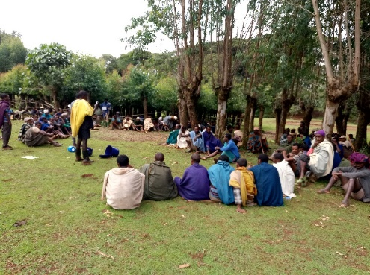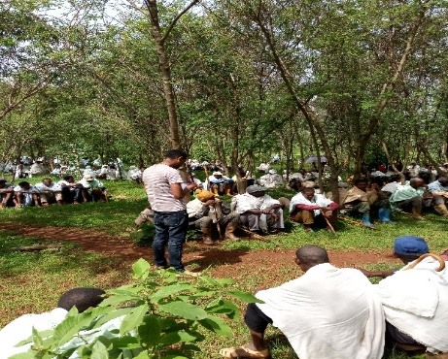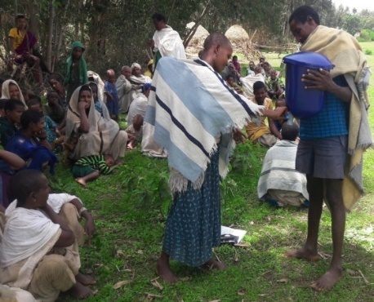
Fig 5: People attending village community sensitization meetings at different sites
2.4 Chlorine Dispenser installation

2.4 Dispensers installation
Dispenser installation training was given to government experts and artisans on installation procedures followed by practical sessions through demonstrations. Those local artisans were selected from the respective communities to attend training and handle the dispenser installation task. For ease understanding of the procedure, dispenser installation procedure was translated into Amharic and given to artisans. Dispensers installation back-checks were conducted as per the agreed protocol as quality control and assurance procedure. The practical training and provision of the Amharic version of the procedure helped artisans to install dispensers within the specified timeline. This could be mentioned as local capacity/empowerment endeavor.
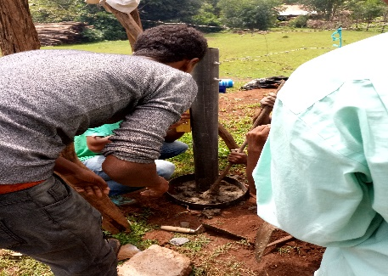
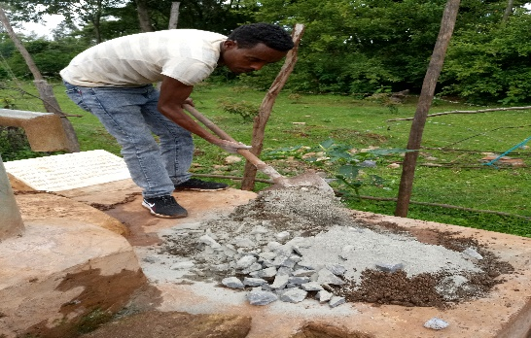
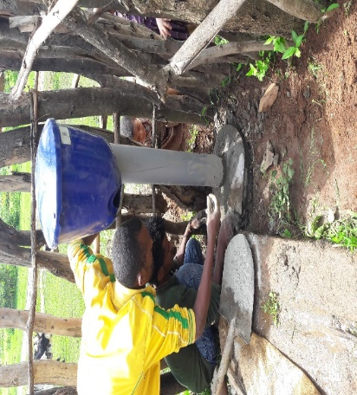
Fig 6: Dispenser installation practical training session for Artesian

During the reporting period, a total of 200 chlorine dispensers were installed as per the the agreed procedures for DSW roll-out. Since then, community members have been using treated water.
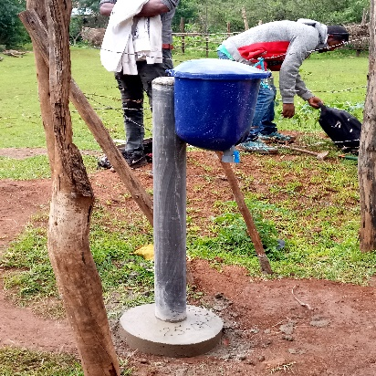
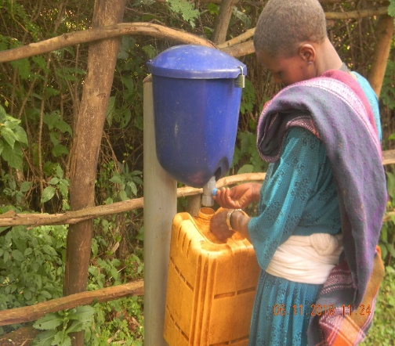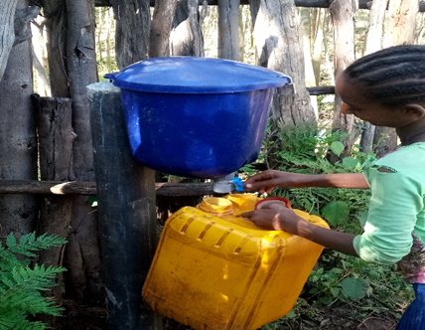
Fig 7: Chlorine dispensers installed at selected water points

2.5 Community Education Meeting (CEM)
Over 12, 000, people from dispensers using community participated community education meetings. CEM was conducted at each water points with high community engagement and participation. On the meetings, dispenser utilization procedures were demonstrated for the beneficiaries. A total of 400 volunteer promotors (200 promotors and the remaining 200 assistant promotors) were elected from water users and nominated as champions responsible for overseeing chlorine refill, status of water treatment during collection and liaison WASHCOs and health extension workers for the proper utilization of chlorine dispensers amongst users. Promotors were informed about their duties and responsibilities and translated and laminated guides were given to enable them know and realize their roles.
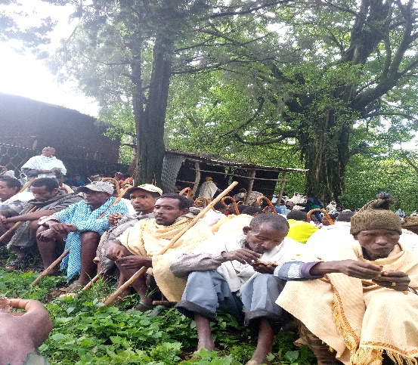
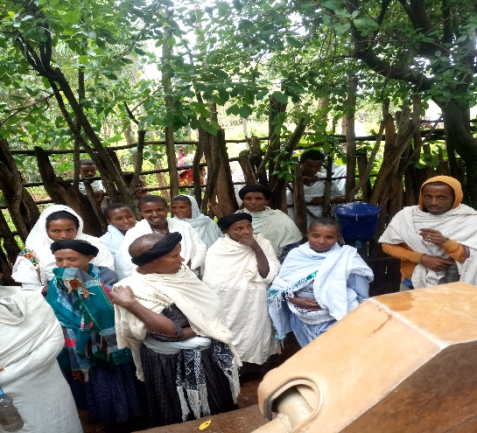
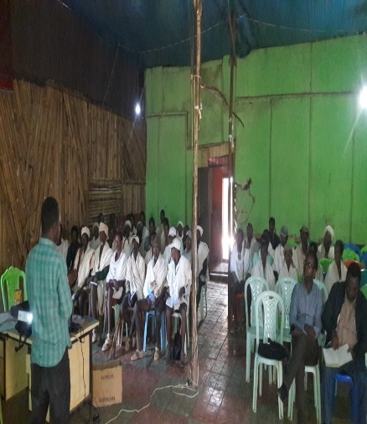
Fig 8: Water users attending community education meetings at different sites

2.6 Monitoring and support activities
The main objectives of DSW adoption monitoring were to ensure quality of activities and gauge the extent to which targeted communities were treating water using chlorine dispensers. For the sake of quality control during the DSW implementation, various methods and tools of monitoring were employed. These include: (1) pilot- monitoring-it was conducted after every three months for the period for which the pilot was supposed to last; (2) scale-up monitoring, it was conducted continuously on monthly basis to check uptake level over time. For both approaches, in-field randomization, which is a form of randomization used by field staff at the water point to determine the households to be visited for monitoring purpose was applied.
Monitoring tools and data collection process: For adoption monitoring, three tools were used to collect data;
- Spot check survey-checks the functionality, empty rates and positioning of the dispenser
- Promoter survey- it checks promoters’ usage of the CD, knowledge about CD, usage, promotional activities and challenges they face regarding the dispenser hard ware.
- Community survey-checks if the HHs are treating their water, have knowledge about the program, promoter responsibilities, attended previous dispenser meetings etc.
To ensure quality over the course of action, the necessary trainings were given to the enumerators before the onset of any survey/data collection. In addition, greater emphasis was given to maintain data collection protocols and procedures during adoption monitoring surveys. As a matter of procedure/protocol, on arrival at a water point, spot check survey was the first to get done and others (promotor and community surveys) followed. To ensure quality at every stage of the DSW roll-out, back-checks were conducted. These include: verification back checks to check the status of water points selected for dispenser installation, community education back-check survey to verify whether or not the necessary contents were covered during CEMs, installation back check survey to confirm quality of installation, and targeted back check- it’s been conducted at selected water points following results from any outlier report. This survey was specifically meant to explain abnormal reduction or increase in adoption which the data cannot explain. Adoption monitoring surveys and joint visits were conducted with a collaborative efforts of MWA, evidence Action and program partners. Results of all adoption monitoring and spot-check visits were shared with program partners and government stakeholders.
The main activities accomplished in connection to the DSW pilot II include:
- A two-week training was provided to government staff on dispenser installation, utilization, maintenance and sustainable management. Twenty five people from government and implementing partners attended a two weeks training of trainers conducted on dispensers for safe water (DSW).
- Different stakeholders sensitization meetings conducted with government people at Zone, district & Kebele levels
- Water point verification surveys conducted to identify 200 community water sources qualified for chlorine dispenser installation.
- Village-level community sensitization sessions were conducted to enlighten water users on the technicalities of using chlorine dispensers.
- 200 chlorine dispensers were installed at community water sources fulfilling the minimum requirements.
- Dispenser installation back-checks were done at all water points for quality assurance.
- Community education meetings were facilitated by trained government people and community promotors in targeted communities
- The procurement and delivery of the 200 chlorine dispensers and liquid chlorine was carried out.
- Program partners purchased the input (liquid chlorine) made available for use at least for a year. But, the user community are expected to cover the cost of chlorine solution by themselves after the bridge period. Here, preparatory activities were accomplished and users were informed on the need to use the money from water fees to for sustainable functioning of dispensers alike water points.
- Findings of the adoption monitoring survey conducted at randomized villages show considerable amount of chlorine dispenser uptake level.
- Promotors, assistant promotors, water care takers and local artisans were trained on dispenser installation, chlorine refilling and operation and maintenance across all sites.
- Separate awareness creation sessions were organized for students and teachers to enable them understand the purpose of DSW and support the community sensitization work to ensure sustainability of the service.

Table 3: Outputs from implementation of Dispensers for Safe Water Pilot
Indicators | Target | Achieved
# of chlorine dispensers implemented | 200 | 200
# of people using chlorine dispensers | 20,000 | 57,450
# of Healthcare facilities dispensing chlorine to DSW | 8 | 6
Chlorine supply chain development | 1 | On progress
# of learning outputs from DSW | 4 | 3
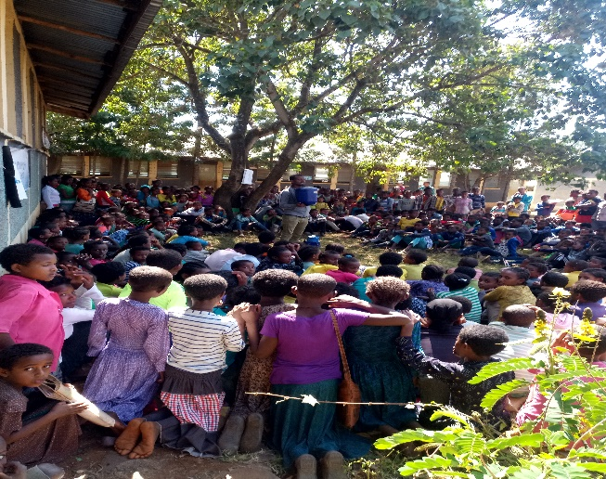
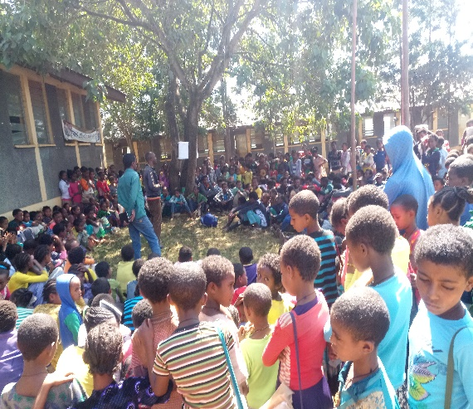
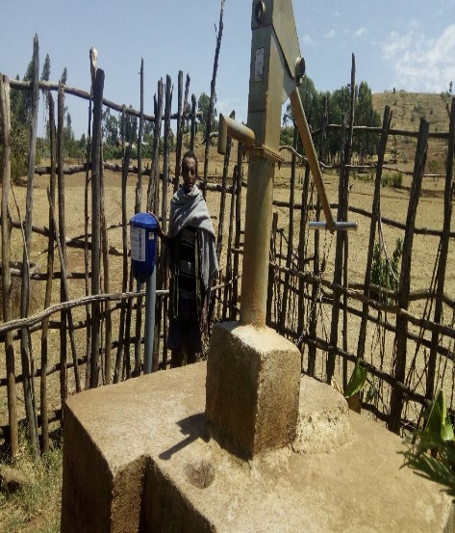
Fig.9: Students attending dispenses awareness creation sessions
Fig 8: Water users attending community education meetings at different sites

Goal 2: Develop a detailed five-year MEL framework and program proposal aligned with the CNHF safe water strategy and applicable to the Ethiopian context.

A number of activities were accomplished as planned to meet this goal. These include: partnership development followed by sets of assessments to assess and investigate the status of WASH services and systems in three districts; system strengthening; district WASH SDG planning in collaboration with local and regional government, and then a detailed MEL framework and program proposal were developed.
1. Assessment for master planning
A strategic plan aimed at reaching full coverage required a robust assessment of WASH services at household, community & institution levels, local government capacities to manage the water services, explore the existing gaps in service delivery and map out resource acquisition and allocation mechanisms for the WASH sector. In connection to this, MWA and program partners have conducted range of assessments to assess and analyze local and regional context and come-up with doable approaches to achieve full-coverage. Here, MWA utilized a considerable amount of resource (staff time, material and money) for data collection, analysis and generating evidences for planning and decision making. For the assessments, local and regional government staff were actively engaged in the design/review of tools for data collection, the actual field work (data collection), data analysis and generating results. To validate data collected from different sources, assessment findings were presented to district government staff and valuable inputs were incorporated to enrich assessment results.

Table 4: Summary of assessments conducted in the bridge period
# | Type of assessment | Data collected | Purpose
1 | Asset management | Primary and secondary data on management of water facilities both in rural and urban settings. | Capture water governance and functionality information
2 | Life cycle cost analysis | Cost data on on water wells drilling, lifting, construction of super structures, operation and maintenance. The cost data includes both current and life-time expenditure to keep the water system functioning forever. | Assess and analyse life-time cost of water sources per technology options and use as inputs for the costing exercise associated to woreda SDG /master plan preparation.
3 | Local financing assessment | Data on the existing financing entities and available loan products and services in the WASH sector. | Investigate the availability and capacity of MFIs that could support WASH development interventions.
4 | Monitoring assessment | Information on monitoring system in use at region/zone/woreda levels, resource allocation (human, material, finance) for M&E, service authority/service provider performance data. | Assess the monitoring and evaluation system in the region/woreda, identify weakness and devise startegis to address gaps.
5 | Network analysis | Insights on actors/stakeholders position and interaction in the WASH sector, level of collaboration and influence as well as stakeholders’ perception on actors and factors affecting local WASH system. | Conduct stakeholder’s analysis/network analysis and design doable model for strengthening partnership and networking.
6 | Political economy analysis | Data on political and economic landscape in connection to WASH service delivery | To explore the underlying factors that influence WASH services pertaining to the wider political, institutional and social context of WASH sector.
7 | Private sector assessment | Basic information on private sector engagement in WASH service delivery | Assess the current trends and issues in the participation of private sector in accessing WASH products and services.
8 | Service delivery equity analysis | Information on the existing water service level with respect to population served disaggregated by setting (rural/urban), gender, accessibility, inclusion (disability consideration) | Assess and analyse water service delivery in the woreda against determinants of equity/equality; identify priorities in equity and design ways to maintain equity/equality in water service delivery.
9 | Sustainability check | Basic insigts on water service levels, competence of service authority and service providers to ensure sustainability, insights on determinants of functionality and service quality. | Assess water service levels, identify capacity gaps among actors, sort out water point sustainability issues and suggest feasible interventions to address issues of sustainability.
10 | WASH in healthcare facilities | Primary and secondary data on WASH services and systems in HCFs | Capture access & coverage data about WASH in HCFs
11 | Water infrastructure inventory | Information on water facilities, watershed managements, functionality, governance, operation and maintenance. | Capture water access and coverage data
12 | Water resource risk assessment | Primary and secondary data on risk factors for ground and surface water | Investigate water resource risks and mitigation measures
The results of these assessments were used to develop the building block baselines. In addition, assessment results were used as inputs for district SDG/WASH master plan development.

2. System strengthening
Efforts were exerted to strengthen the MWA consortium internally as well as support structures and processes of government partners at different levels. In this regard, different activities such as: various human and institutional capacity building endeavors at local and regional government structures, improving the backbone roles within the MWA consortium, organizing consultative meetings with pertinent stakeholders, delivering presentations on WASH systems from local and global experiences, sharing learning documents and different trainings were offered on key thematic areas to improve the knowledge-base and skillsets of those government and partners staff who engaged in the program implementation to bring improved systems and process towards achievement of the sustainable WASH services.
Table 5: Type of trainings and participants during the bridge period
S/No | Type of training | Duration | # of participants
1 | Strategic planning for Non-Business sector | 5 days | 35
2 | DSW training of trainers (ToT) | 10 days | 25
3 | SSA training and planning workshop | 3 days | 45
4 | Water Resource Management | 5 days | 25
5 | Project Implementation through Facilitated Approach | 4 days | 17
6 | District WASH SDG Planning/training | ? | ?
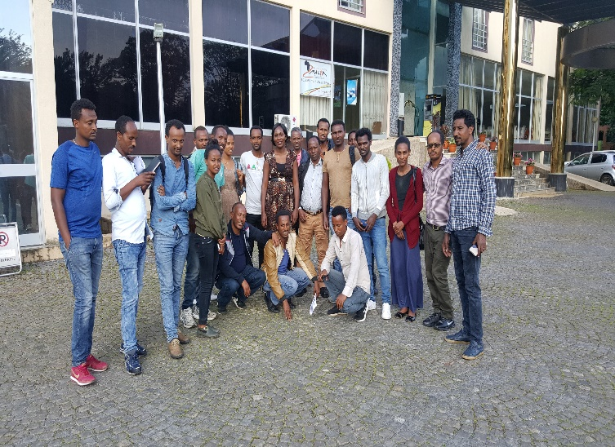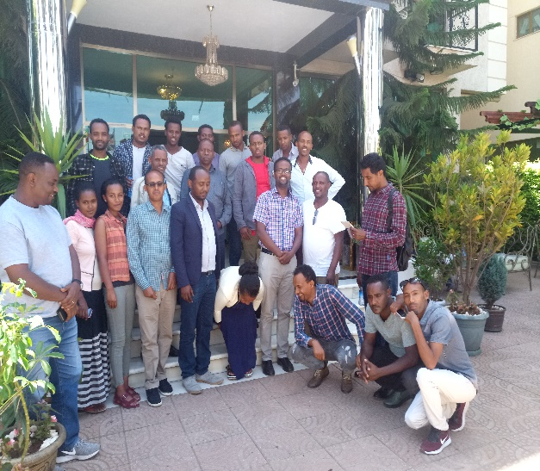
Fig 10: DSW training of trainer participants (Left); WRM training participants (Right)Water users attending community education meetings at different sites

3. District-wide long-term WASH strategic planning
Successive regional and woreda level workshops were conducted for planning and capacity building to support the district government in preparing long-term strategic WASH plans that guide WASH interventions over the next 12-year. Three districts prepared a long-term coasted WASH master plan which clearly show the identified WASH needs, the required technology options, human & institutional capacities, available resources and strategies indicative of how the government, MWA consortium, other CSOs and the private sector can collaboratively work to achieve full-coverage by 2030.

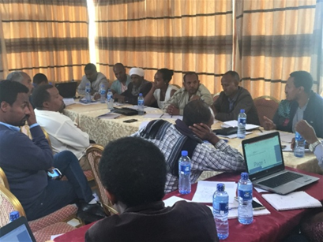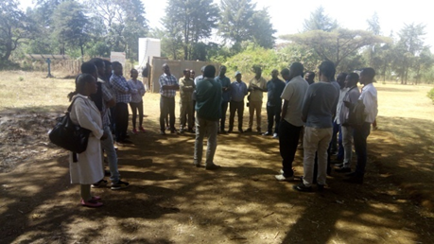
Fig 11: District SDG planning team (Left); CDT members visiting program sites

4. Monitoring, Evaluation & Learning (MEL) framework development
MWA in collaboration with members and government partners has developed a detailed MEL framework that is aligned to the CNHF Theory of Change and Safe Water Strategy. The framework encompasses MWA’s theory of change, theory of action, result framework, motoring tools, learning agenda and plans that will be implemented at local, regional and national levels. For the development of the MEL framework, a series of tasks were accomplished to explore insights and sort out lessons that served as inputs. Some of the activities were: in-depth review of and analysis of assessment result (building block & Qis) analysis; validation workshops conducted to review analysis results; several RF/log frame design and review workshops and compilation of insights using IRC’s template.
5. Program design and proposal development
MWA has followed a participatory and iterative process of program design and proposal development engaging the donor, all program partners, district and regional government stakeholders that enabled to produce a winning proposal where our generous donor (Hilton Foundation) has allowed the required funding for the implementation of a five-year WASH program, which was designed based on the CNHF safe water strategy and a twelve-year district WASH master plans. On top of the main proposal, there will be annual performance review and planning workshop aimed at producing detailed implementation plans (DIPs) with clear targets and segregation of duties between MWA, program partners, district government and regional which collaboratively envision to meet full-coverage by 2030.
For proposal development and district master plan preparation, key findings of the assessment were used to determine technology options and the corresponding costs, set priorities, identify doable models and as inputs for benchmarking. To support the master planning process and sector learning, topics of interest for five position papers were developed. The five topics are financing, monitoring, district master planning for sustainable development goals, capacity development and service-delivery models. All of these five position papers have been drafted during this period and are in an internal review process.

Goal 3: Develop or Strengthen Internal And External Partnerships And Program Support Structures
Partnership development, both internally among implementing partners and externally with government at various levels and with other WASH actors has been a core component of the bridge program.

Internal partnership: There was a coordinating platform called a Core Design Team at which at least one person from each of the six implementing partners (World Vision, CARE, CRS, FH Ethiopia, Helvetas and WaterAid) plus IRC and MWA was developed and a strong partnership has been fostered through intentional activities. This team has engaged together in a series of retreats, meetings, calls, workshops and learning trips in-country and abroad (Ghana).

The established partnership has been further strengthened through regular monthly meetings, consistent email communications and sharing updates as well as team-building activities during review meetings, planning workshops and joint field visits. Through this process, the team has become a cohesive program group and members have served as champions and leaders of the Bridge Program within their individual organizations. Beyond the Core Design Team, MWA Ethiopia Secretariat periodically hosted meetings with Country Directors. The agendas for these meeting focused on program updates, upcoming priorities, and the support needed from the respective Country Directors. These meetings helped to further strengthen partnership by having Country Directors informed, engaged and providing input.
External partnership and networking: This has been developed with three targeted districts, zonal and regional government partners and national level WASH stakeholders. MWA has started a formal partnership signing project implementation agreement with Amhara National Regional State whereby the roles and responsibilities of MWA, Regional Bureau of Finance and Economic Cooperation (BoFEC), Regional Bureau of Water, Irrigation and Electricity (BoWIE) and Regional Bureau of Health (RBOH) were clearly specified for close collaboration. The process of negotiating this agreement along with follow up calls, meetings and launch events have helped to solidify regional relationships. At district level, government officials and experts have actively engaged in bridge program implementation involving inception meetings, program launch events, in planning workshops and in all trainings as well engaging in assessments and field-level activities that have taken place as part of this collaborative bridge program.
For instance, district government officials led their respective SDG WASH planning process, they were involved in trainings on both self-supply acceleration, dispensers for safe water, strategic planning, water resource management, took part in different assessments as data collector and supervisor, monitoring and implementation of chlorine dispensers, officials helped to oversee the progress of the bridge program activities, they also involved at the regional and district level program review and reflection workshops. Many of the meetings and events were held at targeted districts and regional levels just to create buy-in for the district-wide approach, to support moving past ‘business-as-usual’ WASH implementation, and to strengthen both internal and external partnerships. Thus far, the reflections captured from government partners during these meetings clearly indicate the existing buy-in on the approach and strong commitment to support the implementation of the five-year program in order to achieve the ultimate goal ‘’achieve full-coverage by 2030’’.
As way forward, MWA has replace the Core Design Team with Core Program Team for the successful coordination of the next five-year program and essential meetings, workshops and activities are expected to continue through a well-organized hub roles at national and regional levels.
Strengthening program support structures: MWA and IRC have collaboratively worked on two main areas during the bridge program period. The first area is strengthening the backbone hub role of MWA internally. To realize this key task, activities such as presentations from experts, sharing of documents for learning, and intense and ongoing discussions have taken place to increase knowledge and capacity and also to improve systems for planning, using shared measurement system and support the consortium’s work towards collective impact and shared vision. The second piece of strengthening program support is external and primarily applies to supporting the WASH sector in Ethiopia. Several activities have been conducted during this time period to support or influence the broader sector. First, several learning documents have been developed including: self-supply endline evaluation, self-supply learning brief, learning documents on DSW, SSA , district SDG planning process, delivering presentations at national and global WASH events and sharing learning notes with actors.
A specific example of MWA’s work at the national level is related to the One WASH National Program.MWA has contributed a lot for the OWNP I review and OWNP II planning endeavors. The evaluation work was conducted by an independent consultant and MWA and other partners participated in the results dissemination event organized by the ministry. The purpose of this meeting was to share the findings from the evaluation and to also validate the findings with WASH stakeholders. MWA provided input on the draft document for OWNP Phase II.
Additionally, evidence is being developed and shared through this program on topics such as government monitoring systems, WASH in peri-urban areas using the Splash method, self-supply acceleration and the use of dispensers for safe water. Aligned with this, all data collected as part of the assessment aspect of this work belongs to government which supports them in their efforts to make evidence based decisions and engage in planning.
Achievements from Matching Funds-Mussie to complete this if necessary
1. Community water supply, sanitation and hygiene (WASH) services
2. Institutional WASH services
General comment
Please describe briefly (2-3 sentences) how your project is progressing toward the ultimate desired impact outlined in your grant proposal.
The targets set for the bridge program were successfully met with a strong commitment and collaborative efforts of MWA, program partners, local and regional government stakeholders.
Describe any notable successes during this reporting period (e.g., with your organization, collaborating organizations, local community, or within the political landscape). How do you plan to build upon these?
There are several notable successes thus far in the program, most of which are related to partnership development. First, the development of a Core Design Team and the instigation of an MOU detailing roles and responsibilities of each program partner have proven highly valuable. This team also serves as the champions of this program within their own organizations and is the link to share program information with and from their home organizations. Having this team has also provided a platform for consistent communication as both MWA and other partners provide frequent updates or share helpful information.
Another key success has been the timely accomplishments of various assessments conducted in three districts involving key stakeholders and the production of several assessment reports and learning documents on different thematic areas.
A third notable success the successful development of government-lead district SDG /WASH master plan to guide the water supply, sanitation and hygiene interventions of three woredas happened due to the strong partnership and enabling environment created during the bridge period. In order to achieve the SDGs and build the needed capacity and ownership within government, this program has set out to intentionally move to put government in the leadership role with NGOs serving as facilitators. .
Describe any challenges encountered during this reporting period (e.g., with your organization, budget, collaborating organizations, local community, or within the political landscape). How have, or do you plan to respond to these?
Below are some the key challenges experienced during this time period for the Bridge Program. As part of the partnership efforts, these challenges were shared with applicable Ethiopia Country Directors so that they could support in mitigating the challenges and continuing to move the program forward.
- Security issues- the unrest in Ethiopia during the bridge program start-up period caused some delays in assessments, trainings and collaborations with government staff as well as in transport of chlorine dispensers due to safety and shipping method.
- There was some delay in finalizing the regional program agreement due to government schedules and availability and the required negotiation and budgeting processes. This challenge resulted in some program aspects starting later than planned and some delay in internal budgeting and thus internal sub-agreements.

To overcome these challenges, program partners worked closely together to proceed with activities wherever possible. For example, during the times of unrest, partners proceeded with other activities that did not require travel or field visits in order to continue making progress. In some cases, partners or MWA helped to cover the activities of those who did not have the necessary staffing in place. Country Directors and other organization leaders were informed of issues, such as commitment to DSW and SSA, to obtain their help in moving things forward. Challenges and issues are discussed regularly by the Core Design Team so that things are transparent and challenges are mitigated where possible. However due to these delays and the sequential timeline required by large pieces of this program, CNHF and all program partners agreed that the addition of four months to the program was helpful for successful outcomes.

Please list any changes to project staff during this reporting period.
During this time period MWA hired a new Ethiopia Program Director who has taken a key leadership role in ensuring program progress and quality. Several program partners have hired new staff to do implementation work as part of this program, but no other key staff from MWA or partner leadership have changed relative to this program.
Do you anticipate timely completion of the project as outlined in your proposal? Yes No
Even if there were some restraining factors that we encountered during the beginning of the program, MWA and partners have accomplished most of the deliverables set due to the No Cost Extension time allowed by our generous donor.

Optional: What recommendations, requests, and/or questions do you have for us?
Please provide copies of printed publications referencing this project and/or copies of any publicity given to this grant. Please comment on them as desired.
Budget Report
Instructions:
Please complete the budget report Excel template provided with your sub-grant letter.
Please complete the Other Funding Sources portion of the budget report included at the bottom of the budget report Excel template. Expenditures must be reported against the approved budget submitted with your most recent approved proposal. If the budget has been revised, please use the most recent approved budget.
Please submit a copy of the organization’s most recent audited financial statements.
Please address the following questions:
Please explain any line item variance greater than 15%.
Please explain any line item variance greater than $25,000.
If interest was earned on grant funds during this reporting period, please state how much interest was earned and how the interest was applied to the grant objectives.
No interest was earned.
Please provide any additional comments you may have about budget expenditures and variances to date.
If re-granting occurred, please use the table below to list each sub-grantee, amount granted, and purpose (add or delete rows as necessary).
Sub-grantee | Budget in $ | Expenditure in $ | Variance in $
CARE | 303,845
Catholic Relief Services | 120,000
Evidence Action | 59,832
FH Ethiopia | 72,259
Helvetas | 72,758
WaterAid | 187,009
World Vision | 99,959

ANNEXES

1. Case Story on DSW FROM FH ETHIOPIA
FH Ethiopia in collaboration with woreda water office assessed the effectiveness of dispensers in Dera woreda. During field assessment, random sampling method was used to select the chlorine dispenser user community. Geregera kebele, Kushashlame villadge water point which has 23 households and 113 family members was selected. Discussions were conducted with beneficiaries that include the number, age and sex balance of the water users at a particular water point/dispenser to see the impact/outcome of the effort.

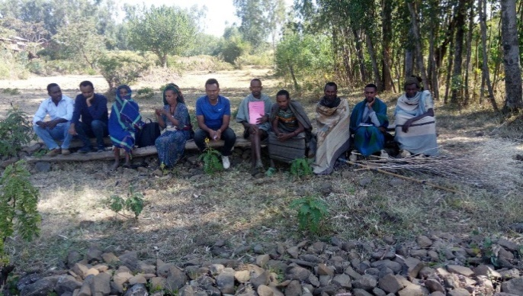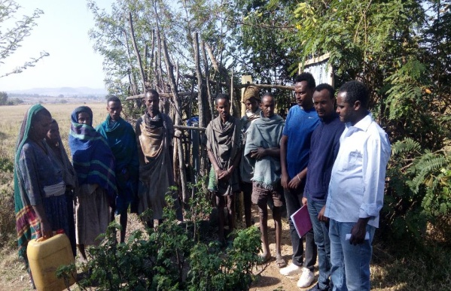
Figure 1 General discussions with the beneficiaries about the success of the DSW

W/ro Angach Setegn is a 35 years old woman; lives in Kushashlame village of Geregera Gebtsawit Kebele in Dera district of South Gondar Zone. She is married and has got three sons and one daughter. She is a small holder farmer and her source of income is traditional agriculture. She lives in a poor economic situation in the community. According to W/ro Angach’s explanation, the previous water source was far away from her village and takes her more than one hour to go and come back home. Moreover, the water was not clean because it is not protected. As a result of domestic and wild animals use of the same water source.This poor quality water has affected the health of her family and other people in the locality.

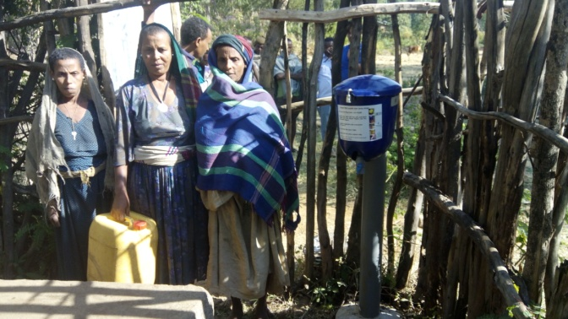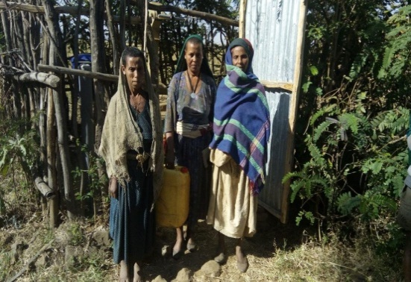
Figure2: W/ro Angach Setegn with promoters at her left and right.
She said that they were suffering from water borne diseases and this also influenced the productivities of the family. The distance of clean water source caused to spend a lot of time for fetching water. Also, due to water borne disease, her children would often absent from school and failed exams.

W/ro Angach said that herself & her villagers requested the woreda water office so many times to assist them in accessing safe and clean water but their question didn’t get quick answer. “Now a day, thanks to God we got safe and clean water source dug near to our village and coupled with liquid chlorine dispenser” said Angach. She added that, the government in collaboration with other actors such as MWA and FH Ethiopia hold back our suffering from water borne diseases and traveling long distance. She finally winded up her speech with sustainability of the chlorine dispenser, she said, they would carefully safeguard the water scheme and chlorine dispenser to serve them for long period and every members of the water user shall contribute per month for maintenance and chlorine purchase.

Ato Asmamaw, the other member of the community and one of the local WASH promoters said that trainings were provided by the woreda water office continuously on the applications of chlorine dispenser. Thus, it helped them equipped with necessary skill and knowledge. On top of it, he explained that before they start using the chlorine dispenser’ his children have faced water borne diseases frequentely. Now, his children are healthy and properly attending school days. Economically he is productive with no loss of time and money by water born disease and able to accomplish his field work during the crop harvesting season. Socially he had a time to discuss with his neighbors about the use of good quality water. Environmentally, the water point is free from open defecation as his house is near to the water point, it means a lot to his family. The water point users agreed and constructed their own household latrines.

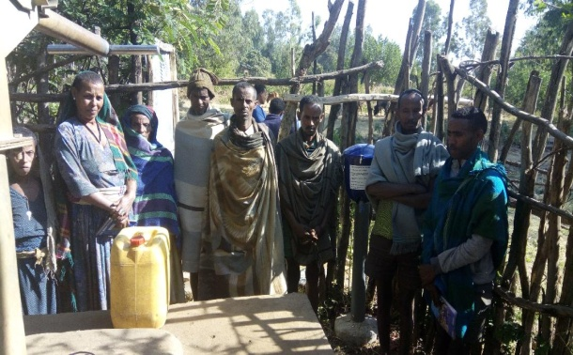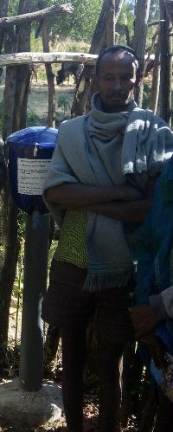
Figure 3: Ato Asmamaw Tebabal & other beneficiaries

Finally, he has explained the sustainability issues with DSW, “though we do have money at the bank we don't opt to utilize it for every maintenance”. Additional contribution is possible whenever maintenance and chlorine purchase is required he said. For any major maintenance we do have the woreda water office phone number posted at the water point we can give them call and contact them for technical support when needed.

Ato Belachew Gedamu, woreda water and energy office, water management and infrastructure administration head. He said that previously they do chlorination directly at the well; this kind of chlorination had a challenge; they don’t exactly know the volume of water in the well to do sufficient chlorination but with DSW, it is possible to manage the dosing rate. Such a technology simplifies the burden of the community as well as the woreda water office.
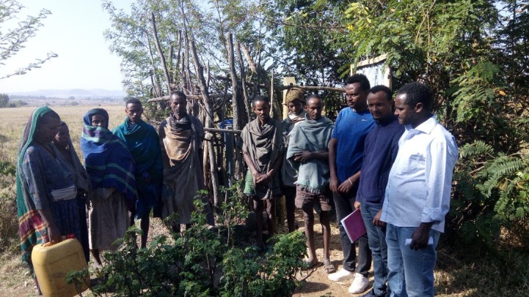
Figure 4: Belachew Gedamu, Woreda Water Office
He explained that in Dera woreda, fifty water points were selected for chlorine dispenser installation and number of procedures were addressed during its implementation and the office water quality expert was highly involved along the processes. During installation processes capacity building/awareness creation on WASH for DSW user community was conducted in parallel. Promoters have laminated manual which has some key messages posted on the DSW bucket. Underneath the message, woreda water office phone number is included. The users can give call to woreda water office when support is needed.

