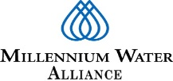
MWA Sustainable WASH Project in Amhara National Regional State
WASH Focus in Three Woredas: Dera, Farta and North Mecha

SWP Year II-First Quarter Progress Report
(July 1, 2020 –September 30, 2020)

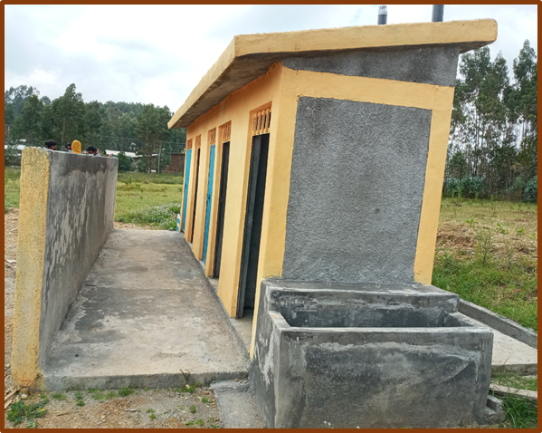

Improved toilet constructed at Hiruy Aba Aregawi Primary School, in Farta

September 2020
Addis Ababa

Table of Content
1. Introduction 2
2. Background 3
3. Project Achievements 4
3.1 Partnership development and system strengthening 5
3.2 Community water supply 6
3.3 School WASH 6
3.4 WASH in Healthcare Facilities 7
3.5 Dispensers for Safe Water 7
3.6 Self Supply Accelaration 7
3.7 Sanitation and Hygiene Promotion in the Community 8
3.8 Monitoring, Evaluation and Learning 8
4. COVID 19 Prevention, Mitigation and Emergency Response 9

- Introduction
The Millennium Water Alliance (MWA) is a permanent coalition of leading humanitarian and private organizations that convenes, integrates, and influences critical players in the business, technology, government and NGO sectors to supply safe drinking water and sanitation (WASH) to millions of the world’s poorest people in Africa, Asia, and Latin America. Founded in 2002, MWA tests, innovates and scales effective and sustainable solutions towards this goal.

MWA works with governments, corporations, foundations and other NGOs to advance best practices, share knowledge, build collaboration and advocate for greater commitment to achieve sustainable WASH services. MWA has been implementing WASH programs in Ethiopia since 2004. The current Conrad N. Hilton Foundation (CNHF) supported ‘Sustainable WASH Project’ in three woredas of Amhara region is the collective work of MWA and program partners that include: CARE, Catholic Relief Services, FH Ethiopia, IRCWASH, WaterAid Ethiopia and World Vision. There are also strategic partners supporting Sustainable WASH project in various technical aspects which include: Splash, CDC and The Woods Institute of Stanford University. While different members and strategic partners focused on some specific aspects of the project, the results are presented collectively as the work of the MWA. In the discussions where “MWA” is mentioned are meant to be inclusive of the program members and strategic partners as a whole though the extent of engagement vary depending on project components as per the roles and responsibilities stipulated in a detailed memorandum of understanding between MWA and program partners. This three months progress report provides summary of project accomplishments and progresses made during the 1st quarter of Year II (April 1, 2020- June 30, 2020).
- Background Information
Millennium Water Alliance in Ethiopia is currently implementing a five-year project funded by Conrad N. Hilton Foundation. The project is implemented through a consortium of members and strategic partners. The consortium approach promotes collective action and helps to bring collective impact (results). In enhancing collective action, MWA has continued to mobilize and coordinate members’ activities which have provided a critical mass to reach the target beneficiaries in the three Woredas where partners have geographical coverage.

In enhancing systems strengthening, advocacy and influencing works, MWA and program partners have continued to engage with other stakeholders, including the government at different levels to improve the long-term enabling environment for achieving SDGs in WASH – an advocacy position that has proven to be very difficult for anyone organization to achieve alone. MWA has also continued to promote collective learning through convening meetings and learning events which included core program team meetings, regional program team meetings and thematic learning events at national and regional levels. In addition, the Secretariat has continued to coordinate joint monitoring and supportive supervisions where the team utilizes a common monitoring and reporting system to track progress as well as measure outputs and intermediate results of project interventions.

- Project Achievements
This report summarizes the second quarter (three months) progress from year II of the project duration (July 1, 2020-September30, 2020). Since the period was a typical rainy season, there has not been much progress in WASH facility development. More accomplishments were made in strengthening community structures for sustainable management of water supply systems, data collection for DSW adoption monitoring survey, partnership development endeavors, trainings and local capacity building, frequent follow-up on water quality improvement work as well as systems strengthening activities at woreda and community levels. MWA has also facilitated some regular meetings and convening to track progress, share learnings and design ways to move the project forward.

- Partnership development and system strengthening
MWA and program partners conducted meetings with government stakeholders at different levels. For instance, there was a regional WASH systems strengthening workshop conducted involving about 38 participants from regional, zonal and woreda level government stakeholders and program partners. Similarly, program partners facilitated Woreda level steering and technical committees meetings conducted to assess progress and accelerate collective efforts to move the SWP forward addressing issues. Similarly, regional level consultative meetings were held to strengthen systems that ensure sustainability of WASH services both at institutions and in the community. Woreda level SDG plan revitalization workshop at Dera District
Woreda leads organized woreda-wide SDG plan review workshop. The workshop was organized in collaboration with MWA and IRC WASH. The workshop helped all stakeholders to understand better the long term SDG plan and used it as a mechanism to ensure ownership of the master plan. Woreda Water Offices have started reviewing their annual plan against the 12-year master plans. It was found out that annual implementation plan revision is required to incorporate changes that the team has learned while implementing the Sustainable WASH program. To make use of the advantage of the woreda level master plan document, it was advised that woreda level technical team and woreda WASH team should work hand-in-hand with other responsible government authorities to succeed with the plan.
The other notable achievement was that SWP Year II planning workshop was conducted in the presence of woreda steering committee, woreda technical committee, and planning officers drawn from finance and economic offices. In the planning workshop held in North Mecha woreda, a total of 22 government officials’ and 8 project staffs were participated. Besides, CRS and WAE conducted quarter review meeting with woreda steering committee. During the meeting, partners presented semi-annual plan-vs.-achievement, challenges encountered, and remedial action taken during project implementations.
To support government efforts in the prevention and mitigation of COVID-19, discussions were conducted at regional and woreda levels, different personal protective equipment (PPEs) and hygiene improvement materials were provided to schools and health facilities; logistics supports were provided to local government offices and partners participated in the meetings conducted on the pandemic.
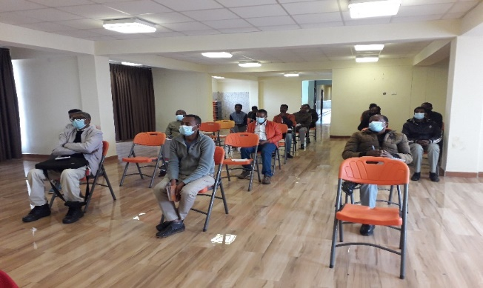
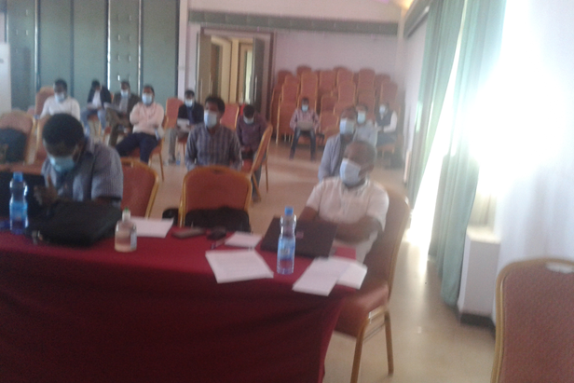
Picture 1: People attending WASH systems strengthening workshop (Left); Woreda Steering Committee Meeting (Right)
- Community water supply
Development of new water schemes: Since this reporting period was the main rain season, there was no much progress in terms WASH facility development except working on the ongoing water supply systems. As part of safe water supply improvement, WaterAid has managed different activities related to the multi-village water supply system in Ambo-mesk kebele. The system includes the construction of a 75m3 collection chamber, 100 m3 elevated reservoir, 8 community water points and pressure and distribution pipelines. The construction is still on-going and currently the construction work for 75 m3 collection chamber, pressure lines/distribution lines, and 8 community water points were completed and well-fenced. In addition, 100m3 elevated reservoir, air release valves and the respective collection chambers are under construction.
Members and government partners have done some preparatory works for the upcoming facility development. In this regard, selection and identification of kebeles and sites for construction works conducted, and in consultation with the woreda water office staffs community demand request format revised and ready for distribution of demand request. The pre-preparation works like the procurement plans, etc is also initiated.

Water point rehabilitation works: Building the capacity of local government and the user community to fix damages and breakages at community water points has been an integral component of SWP. In this reporting period, much attention was given for assessment and water scheme identification for future upgrading, rehabilitation and expansion works. Program partners and woreda Water Offices have paid visits to targeted communities and selected non-functional water points that will be fixed over the remaining months of the year. For instance, a total of 50 existing non-functional water supply systems were identified in Farta with a detailed information on the required rehabilitation/maintenance levels for each scheme, the specifications of the required materials for maintenance/rehabilitation and determined timeliness for operation and maintenance.

Water governance and capacity building: program partners have supported woreda water Offices to establish and strengthen the capacity of WASHCOs and WUAs to enable them sustainably manage water supply systems. Discussion was held on improving water governance through community scorecard approach, which helps to capture water users’ satisfaction levels and feedbacks in order to improve the scheme management practice. CARE has facilitated the discussion as thematic lead. Some partners like FHE and WVE have conducted an assessment to check WASHCOs willingness to form WUAs in Dera Woreda. They learned that there were WASHCOs which wanted to grow to water users’ association level. The woreda WASH technical team is currently conducting potential assessment on it and will share the report. Based on the decision and support notes from the woreda WASH technical committee, partners will keep supporting the establishment of Water Users’ Association as per the existing government guidelines.
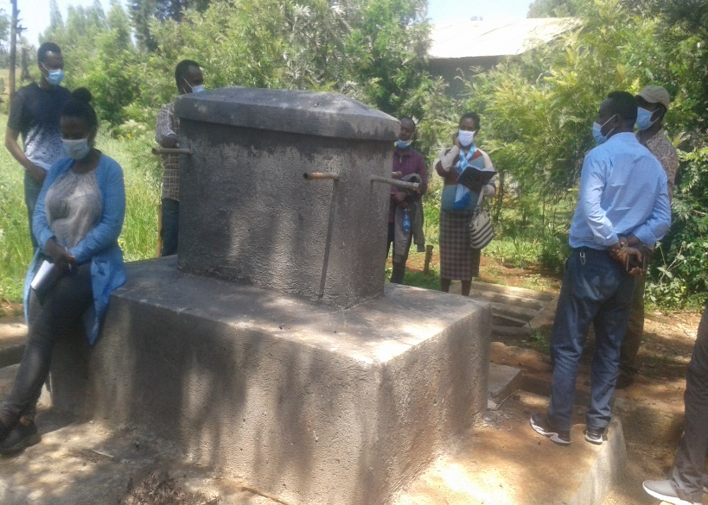
Picture 2: New community water point constructed at WVE site, in Dera
- School WASH
During the reporting period, WASH infrastructure development work was not implemented since the schools were closed for COVID-19 and the rainy season. However, some support activities were carried out. The most important piece of work was the capacity building training organized for school guards on school WASH maintenance and safe water provision. The aim of the training was to equip school guards on school WASH maintenance, operation and safe water provision (water treatment & handling). A total of 11 participants (all are male) took part in the training. Training was focused on participants’ behavioral change to wards owning the school WASH infrastructure built by different actors at school and awareness creation on how to operate and maintain WASH facilities within school compound including water treatment and safe storage.
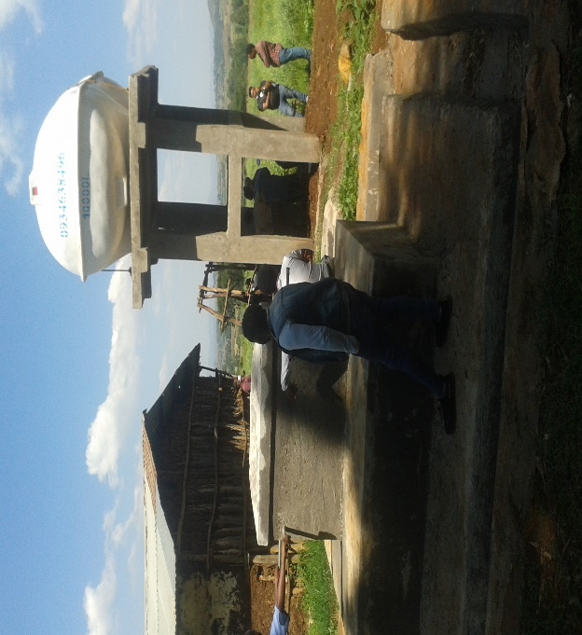
Picture 3: Improved toilet constructed at school in Fartal (Left); Water facilities constructed at school, in Dera (Right)
- WASH in Healthcare Facilities
Continuous follow-up and technical supports were provided to sic (6) health centers implementing the Clean Clinic Model (CCM) in three woredas. In addition, a joint field visit was paid to these health facilities to check progress and observe the changes happening in service delivery. Those health facilities implementing CCM have shown promising change in terms of accessing WASH services and managing the existing systems for better clinical and outreach services. Partners have also accomplished other activities including: discussion on plan and achievement of the health center; monitoring waste disposal system of the health center including the presence colored waste bin in the rooms; strengthening well cleaned environment in the health center and assessment of customer satisfaction on the services.
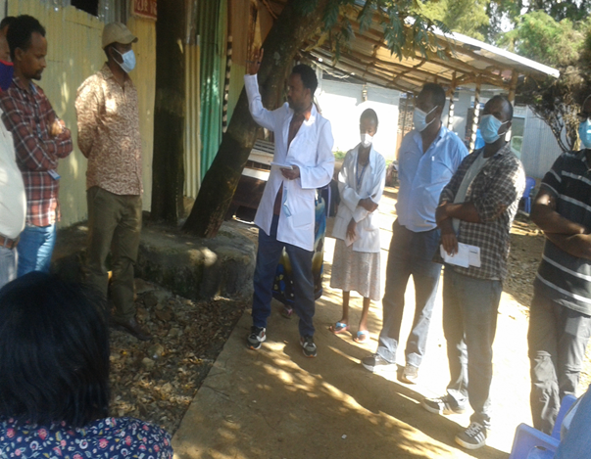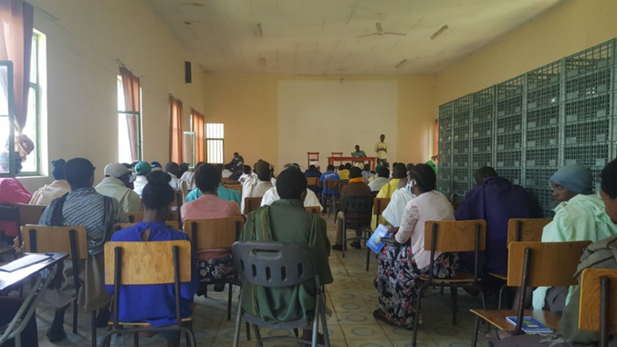
Picture 4: Discussion with health staff at Anbesamie Health Center (Left); Discussion with cleaners at Watet Abay Health Center (Right)

- Dispensers for Safe Water (DSW)
Three implementing partners (CARE, CRS &FHE) have provided the necessary supports for the sustainable use of chlorine dispensers installed at 240 community water points (80 dispensers/woreda). Different back-checks and monitoring surveys were carried out during the reporting period to assess utilization rate and check the status of dispensers installed at community water sources. The adoption monitoring survey was conducted at all sites where chlorine dispensers were installed since 2017.The assessment results show that there need to be much work to improve utilization rate of chlorine dispensers as water quality improvement option in three woredas (Dera, Farta & North Mecha).
For adoption monitoring, at each of the water points sampled for monitoring, the field staff conducted four types of interviews:
Community survey: interviews with eight randomly selected households collecting their water from the water point with a dispenser, to understand their knowledge and use of the dispensers as well as their household practices when collecting, treating, and storing water. Households were also asked about their interaction with the promoter.
Promoter survey: interviews with the volunteer promoter of the dispensers to understand activities they conducted to promote usage of the dispensers and the challenges encountered in the case of promoting the dispenser.
Spot check: a visit was also conducted on the dispensers to inspect the dispenser hardware and determine its functionality.
WASHCO survey: interview with the person in-charge of charging chlorine user fees at the water point (to check feasibility of pay-to-use approach).
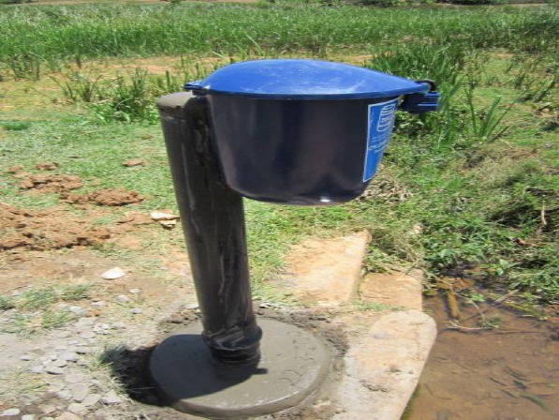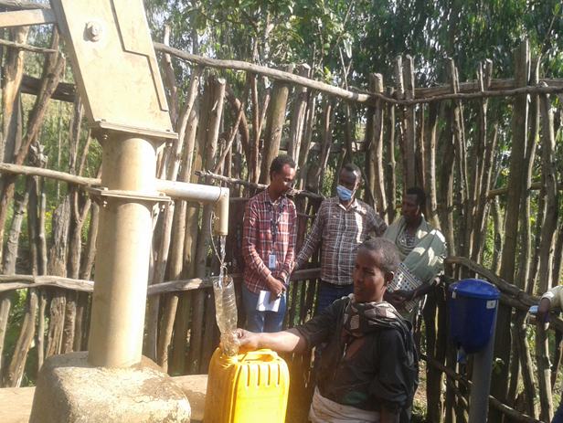Picture 5: Chlorine dispenser installed at water source (Left); People collecting water from a water point with dispenser (Right)

- Self-Supply Acceleration (SSA)
For encouraging households to have their own water supply system, iintensive demand creation and needs identification activities were done in three woredas. Program partners have identified interested households for water source development and upgrading works. Technical supports and follow-up service were provided to households with self-supply wells across three woredas (Dera, Farta and North Mecha).
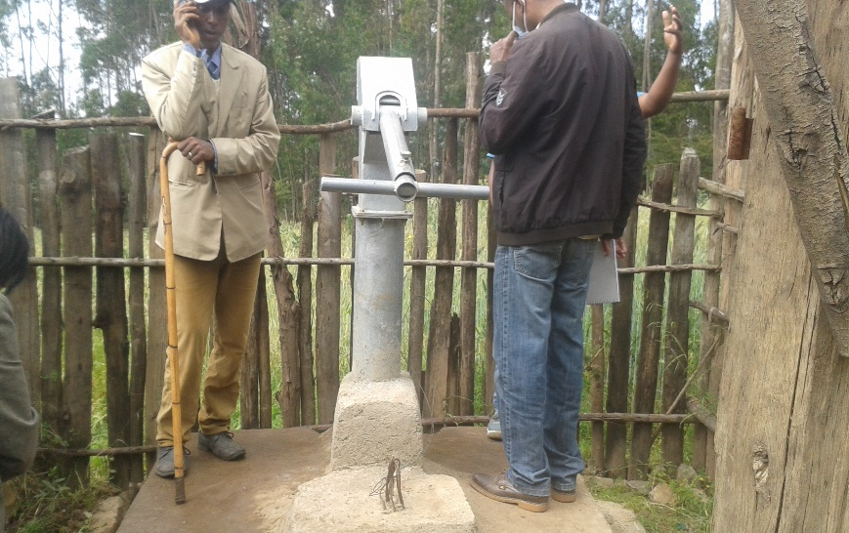
Picture 6: Household self-supply in Awuzet kebele, in Farta
- Sanitation and Hygiene Promotion in the Community
Community level sanitation and hygiene promotion activities were carried out engaging health extension workers and volunteer community promotors. Different participatory and entertaining approaches were used for mass sensitization. In this reporting period, Training on community led total sanitation and hygiene (CLTSH) approach was given for three consecutive days at Arbegebya town for CLTSH committee members of Shemey kebele. In this training a total of 11 participants (M=6 & F= 5) were attended. The aim of the training is to create open defecation free community in Shemey kebele through implementing CLTSH approach. This training comprises both theoretical and practical sessions, theoretical part cover CLTSH tools and elements and also in practical part demonstration of pre-ignition, ignition and post follow-up.

- Monitoring, Evaluation and Learning (MEL)
MWA has continued to promote joint monitoring and collective learning through convening meetings and learning events which included core program team meetings, regional program team meetings and thematic learning events at national and regional levels. In addition, the Secretariat has continued to coordinate joint monitoring and supportive supervisions where the team utilizes a common monitoring and reporting system to track progress as well as measure outputs and intermediate results of project interventions over time. In connection to this, we have been able to convene partners virtually and in-person meetings taking all the required precautions against COVID-19.
Different virtual meetings were conducted for planning, monitoring and review of project progresses. These internet assisted meetings helped to review project progress, create common understanding on situations, identify roadblocks and take remedies on critical issues. Annual review of Woreda-wide SDG plan has been conducted in each of the three intervention woredas. This has helped the Woreda WASH Teams (WWTs) to prepare Annual Work Plans aligned to the 12-Year SDG plan. A joint supportive supervision was conducted to SWP intervention Woredas involving program partners and woreda level government stakeholders to observe the status of WASH facilities and provide technical supports for field level practitioners. Woreda level debriefing sessions were held to discuss and agree on next key steps. In this reporting period, progress updates, annual reports and meeting notes were compiled/consolidated and shared with program partners, the donor and government stakeholders.
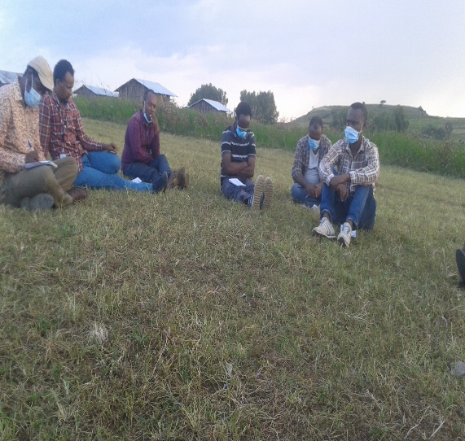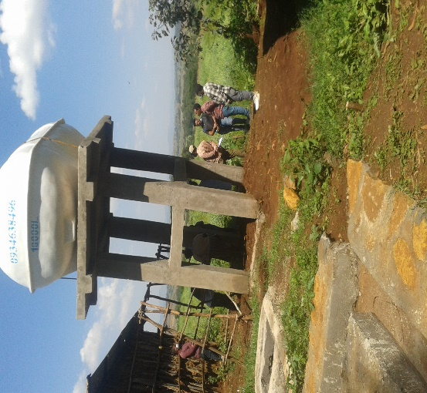
Picture 7: Debriefing meeting after visiting sites in Dera (Left); A reservoir installed at school (Right)
- COVID 19 Prevention, Mitigation and Emergency Response
MWA and program partners have managed several activities in response to the prevention and control of COVID-19 since the first case was identified in Ethiopia, March 2020. MWA and program partners have provided supports for COVID-19 mitigation in three Woredas and at region level. The support included, training of health workers, community level sensitization and messaging, purchase of hand washing facilities, delivery of essential personal protective equipment such as: face mask, eye goggles, heavy duty gloves, and sanitizers, WASH service assessment at quarantine/isolation centers, supply of water containers, detergents and handwashing facilities.

Technical support was provided to the woreda taskforces in coordination and message dissemination efforts using the existing community systems such as health extension workers and other community volunteers through community segmentation by forming small groups of households and home-to-home visits. Technical training was also given on how to address water shortages through rapid rehabilitation of non-functional water sources and availing water at water storages especially for vulnerable community and healthcare facilities.

- Challenges and Resolutions
- Absence of supply-chain for liquid chlorine and dispenser spare parts near the project sites
- The prevailing misperception on the use of chlorinated water among rural community due to low level of awareness.
- Low DSW adoption rate/uptake rate across intervention woredas and those communities from pilot I were not using dispensers.
- The DSW initiative is facing less technology ownership at local level government and community level.
- Price escalation of liquid chlorine at manufacturers and absence of standard for chlorine solution required for dispensers (concentration-1.25 has resulted in low uptake level.
- It was challenging to proceed the implementation of the Sustainable WASH Project activities as planned due to the COVID-19 pandemic.
- Some of the chlorine dispensers installed during the bridge period are run out of chlorine at this time. It is an indicator for the need to establish local chlorine supply chain.
- Lack of coordination amongst stakeholders during planning and implementation in North Mecha
- Lack of information to building a comprehensive MIS as required by stakeholders because of data
- Lack of planning for operation and maintenance at scheme level
- Large gap between information need of woreda WASH actors and available data about schemes
- Lack of construction completion report of water supply schemes from woreda WASH actors. Only 1 report obtained for Dera and 4 for Farta
- Lack of records of tariff collected and expenditure at scheme level in support of expenditure tracking repor
Resolutions taken:
- MWA has been in frequent contact to the National Standards Agency to develop local standards for liquid chlorine.
- DSW was a top agenda during the WASH Systems Strengthening Workshop where all the challenges, restraining factors and potential remedies were raised, discussed and recommendations forwarded.
- Program partners and woreda level government stakeholders were advised to give attention to the DSW initiative to improve the uptake rate.
- Private sector engagement in liquid chlorine manufacturing in and around Bahire Dar would minimize the cost of liquid chlorine. This will be successfully addressed when the national standard is developed.
- Strengthening coordination of stakeholders at all levels
- Continuous advocacy on the need of documentation of historical data related to schemes
- Support woredas to strengthen scheme level planning
- 2 Draft WASH MIS developed to demonstrate the gap between information need and available data and shared with stakeholders
- Support given to government and program partners to plan and report against woreda Masterplans.

